EXPERIMENT No.1

OBJECTIVE: Identification of various electronics, electrical components and study of measuring instruments and sources used in electronic circuits. (i) CRO (ii) Function Generator (iii) Multi-meter (iv) DC Supply

APPARATUS & MATERIAL REQUIRED:- Cathode-ray Oscilloscope, Function Generator, BNC to BNC co-axial cable, CRO Probes, multi-meter and dc power supply THEORY:

1. Cathode-Ray Oscilloscope:

The cathode-ray oscilloscope (CRO) is a common laboratory instrument that provides accurate time and amplitude measurements of voltage signals over a wide range of frequencies. Its reliability, stability, and ease of operation make it suitable as a general purpose laboratory instrument. 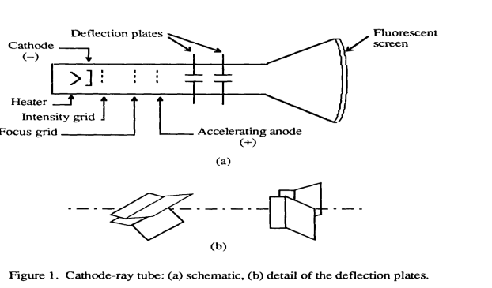

The heart of the CRO is a cathode-ray tube . The cathode ray is a beam of electrons which are emitted by the heated cathode (negative electrode) and accelerated toward the fluorescent screen. The assembly of the cathode, intensity grid, focus grid, and accelerating anode (positive electrode) is called an electron gun. Its purpose is to generate the electron beam and control its intensity and focus. Between the electron gun and the fluorescent screen, there are two pair of metal plates - one oriented to provide horizontal deflection of the beam and one pair oriented to give vertical deflection to the beam. These plates are thus referred to as the horizontal and vertical deflection plates. The combination of these two deflections allows the beam to reach any portion of the fluorescent screen. Wherever the electron beam hits the screen, the phosphor is excited and light is emitted from that point. This conversion of electron energy into light allows us to write with points or lines of light on an otherwise darkened screen.

1. FUNCTION GENERATOR

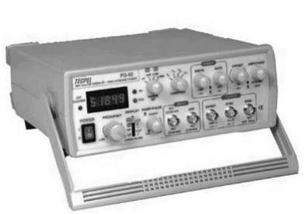

A function generator is a piece of electronic test equipment or software used to generate electrical waveforms. These waveforms can be either repetitive, or single-shot in which case some kind of triggering source is required (internal or external). Another type of function generator is a sub-system that provides an output proportional to some mathematical function of its input; for example, the output may be proportional to the square root of the input. Analog function generators usually generate a triangle waveform as the basis for all of its other outputs. The triangle is generated by repeatedly charging and discharging a capacitor from a constant current source. This produces a linearly ascending or descending voltage ramp. As the output voltage reaches upper and lower limits, the charging and discharging is reversed using a comparator, producing the linear triangle wave. By varying the current and the size of the capacitor, different frequencies may be obtained. Most function generators also contain a non linear diode shaping circuit that can convert the triangle wave into a reasonably accurate sine wave. It does so by rounding off the hard corners of the triangle wave in a process similar to clipping in audio systems. A typical function generator can provide frequencies up to 20 MHz and uses a BNC connector, usually requiring a 50 or 75 ohm termination. Specialized RF generators are capable of gigahertz frequencies and typically use N-type output connectors. Function generators, like most signal generators, may also contain an attenuator, various means of modulating the output waveform, and often the ability to automatically and repetitively "sweep" the frequency of the output waveform (by means of a voltage-controlled oscillator) between two operator-determined limits. This capability makes it very easy to evaluate the frequency response of a given electronic circuit.

1. Multimeter :

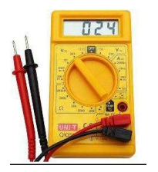

A multimeter or a multitester, also known as a VOM (Volt-Ohm meter), is an electronic measuring instrument that combines several measurement functions in one unit. A typical multimeter may include features such as the ability to measure voltage, current and resistance. Multimeters may use analog or digital circuits—analog multimeters (AMM) and digital multimeters (often abbreviated DMM or DVOM.) Analog instruments are usually based on a micro ammeter whose pointer moves over a scale calibrated for all the different measurements that can be made; digital instruments usually display digits, but may display a bar of a length proportional to the quantity being measured. A multimeter can be a hand-held device useful for basic fault finding and field service work or a bench instrument which can measure to a very high degree of accuracy. They can be used to troubleshoot electrical problems in a wide array of industrial and household devices such as electronic equipment, motor controls, domestic appliances, power supplies, and wiring systems.

4. Power Supply:

A power supply is a device that supplies electric power to one or more electric loads. The term is most commonly applied to devices that convert one form of electrical energy to another, though it may also refer to devices that convert another form of energy (mechanical, chemical, solar) to electrical energy. A regulated power supply is one that controls the output voltage or current to a specific value; the controlled value is held nearly constant despite variations in either load current or the voltage supplied by the power supply's energy source. Every power supply must obtain the energy it supplies to its load, as well as any energy it consumes while performing that task, from an energy source

Bread Board:

A breadboard (protoboard) is a construction base for prototyping of electronics. The term is commonly used to refer to solderless breadboard (plugboard). Because the solderless breadboard does not require soldering, it is reusable. This makes it easy to use for creating temporary prototypes and experimenting with circuit design.

Cc

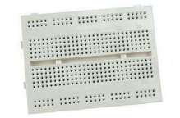

EXPERIMENT NO.2

OBJECTIVE:

To study the PN junction diode characteristics under Forward & Reverse bias conditions.

APPARATUS & MATERIAL REQUIRED: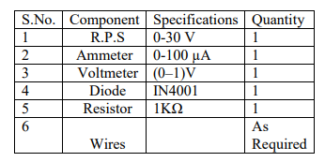

THEORY: A PN junction diode is a two terminal junction device. It conducts only in one direction (only on forward biasing). Forward bias:

On forward biasing, initially no current flows due to barrier potential. As the applied potential exceeds the barrier potential the charge carriers gain sufficient energy to cross the potential barrier and hence enter the other region. The holes, which are majority carriers in the P-region, become minority carriers on entering the N-regions, and electrons, which are the majority carriers in the N-region, become minority carriers on entering the P-region. This injection of Minority carriers results in the current flow, opposite to the direction of electron movement.

Reverse bias:

On reverse biasing, the majority charge carriers are attracted towards the terminals due to the applied potential resulting in the widening of the depletion region. Since the charge carriers are pushed towards the terminals no current flows in the device due to majority charge carriers. There will be some current in the device due to the thermally generated minority carriers. The generation of such carriers is independent of the applied potential and hence the current is constant for all increasing reverse potential. This current is referred to as Reverse Saturation Current (IO) and it increases with temperature. When the applied reverse voltage is increased beyond the certain limit, it results in breakdown. During breakdown, the diode current increases tremendously

CIRCUIT DIAGRAM:

FORWARD BIAS:

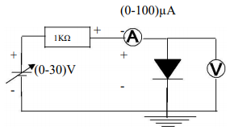

REVERSE BIAS:

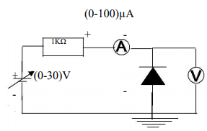

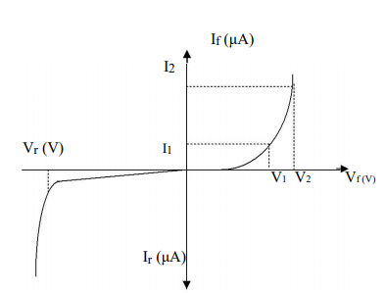

EXPERIMENT NO.3 OBJECTIVE: To study the working of Half Wave and Full wave (Bridge Type) Rectifier. APPARATUS REQUIRED: Cathode Ray Oscilloscope (CRO), Bread board, Transformer, diodes, resistors, connecting wires. THEORY: Diode rectifier circuits The basic half-wave rectifier circuit is shown in Figure 1. The input signal Vin to the rectifier is assumed to be a purely AC signal with a time-average value of zero. Since current passes through an ideal diode only when the input signal is positive, the output signal Vout across the load resistor will be as shown below.

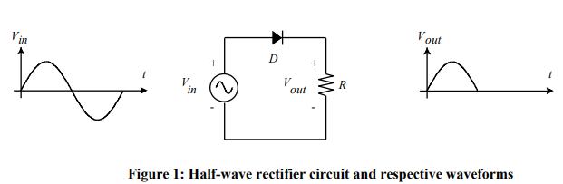

A half-wave rectifier can be connected to the transformer secondary as shown in Figure 2to generate the typical half-wave output signal as discussed before. The half-wave rectifier circuit produces an output signal whose fundamental frequency is the same as the input AC signal.

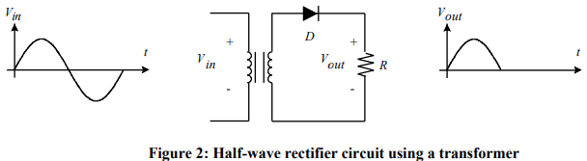

When input AC signal is applied across the bridge rectifier, during the positive half cycle diodes D1 and D3 are forward biased and allows electric current while the diodes D2 and D4 are reverse biased and blocks electric current. On the other hand, during the negative half cycle diodes D2 and D4 are forward biased and allows electric current while diodes D1 and D3 are reverse biased and blocks electric current. During the positive half cycle, the terminal A becomes positive while the terminal B becomes negative. This causes the diodes D1 and D3 forward biased and at the same time, it causes the diodes D2 and D4 reverse biased.

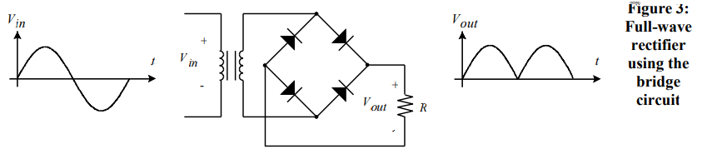

EXPERIMENT NO.4

OBJECTIVE:

To study the application of diode as (i) Clipper circuit and (ii) Clamper Circuit. APPARATUS & MATERIAL REQUIRED:

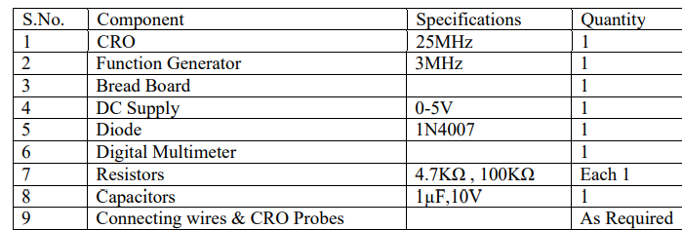

THEORY:

A clipper is a circuit with which the waveform is shaped by removing or clipping a portion of the applied input signal waveform without distorting the remaining part. Clippers fall into the general category of wave-shaping circuits. The function of a clipper is to limit the amplitude of a signal to some particular maximum positive or negative value. Clipper can remove signal voltages above or below a specified level. Clipper Circuits: Clippers are networks which clip away part of the applied signal. Clippers are used to: • Create a specific type of signal. • Limit the voltage that can be applied to a network. Clipper circuit consists of: • AC-source. • Diode. • DC-Source (to shift the operating point to the required value). Clamper Circuits: Clamping circuits shifts or change a signal to different d.c. level. Clamping circuit introduces a d.c. level to an a.c signal. Clampers are networks that clamp the input signal to a different dc level, but the peak-to-peak swing of the applied signal will remain the same. Clamper circuit consists of clipper components plus capacitor. CIRCUIT- DIAGRAMS: Clipper Circuits:- This circuit limits an input voltage to certain minimum and maximum values. In the circuit in Figure-1, as long as VI is less than VB1, then the diode will be reverse biased (an open circuit). In this case, the output voltage will track the input voltage. If VI exceeds VB1 then the diode turns on and then Vo will be VB1 thus this circuit limits the output voltage to less than VB1. By rearranging the components, variations on this circuit can be achieved.

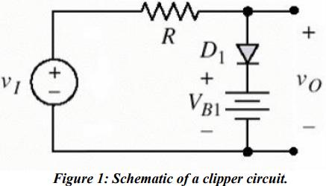

Clamper Circuits:-

This circuit works by allowing the capacitor to charge up and act like a battery. This is the voltage across the capacitor depends on the input waveform, the output maximum( or the minimum depending on the orientation of the diode) will be clamped to a fixed reference point .

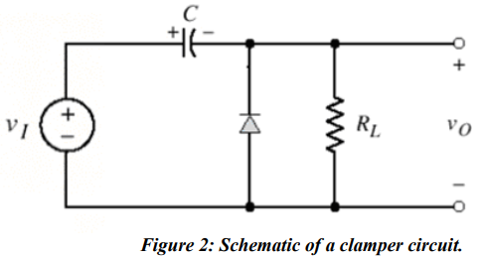

EXPERIMENT NO.5

OBJECTIVE:

To study the application of Zener diode as a voltage regulator.

APPARATUS & MATERIAL REQUIRED:

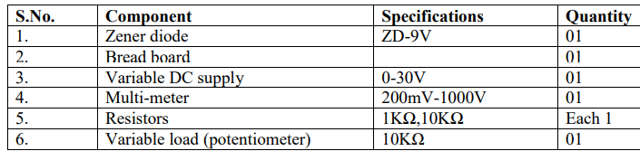

CIRCUIT DIAGRAM:

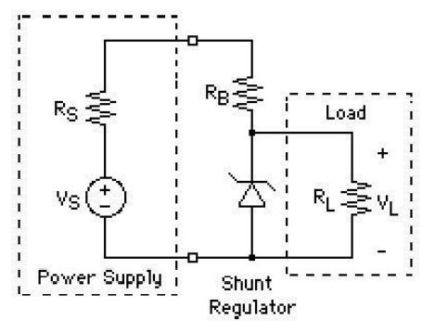

THEORY:

VOLTAGE REGULATION:-

Voltage Regulator: A voltage regulator circuit is required to maintain a constant dc output voltage across the load terminals in spite of the variation: ¬ Variation in input mains voltage ¬ Change in the load current ¬ Change in the temperature The voltage regulator circuit can be designed using Zener diode. For that purpose, Zener diode is operated always in reverse biased condition. Here, Zener is operated in break-down region and is used to regulate the voltage across a load when there are variations in the supply voltage or load current. The figure shows the Zener voltage regulator, it consists of a current limiting resistor Rs connected in series with the input voltage Vs and Zener diode is connected in parallel with the load RL in reverse biased condition. The output voltage is always selected with a breakdown voltage VZ of the diode.

The input source current, IS = IZ + IL………….. (1) The drop across the series resistance, Rs = Vin – Vz …….. (2) And current flowing through it, Is = (Vin – VZ) / RS ………….. (3) From equation (1) and (2), we get, (Vin - Vz )/Rs = Iz +IL ………… (4) Regulation with a varying input voltage (line regulation): It is defined as the change in regulated voltage with respect to variation in line voltage. It is denoted by ‘LR’. In this, input voltage varies but load resistance remains constant hence, the load current remains constant. As the input voltage increases, form equation (3) Is also varies accordingly. Therefore, Zener current Iz will increase. The extra voltage is dropped across the Rs. Since, increased Iz will still have a constant Vz and Vz is equal to Vout. The output voltage will remain constant. If there is decrease in Vin, Iz decreases as load current remains constant and voltage drop across Rs is reduced. But even though Iz may change, Vz remains constant hence, output voltage remains constant.

EXPERIMENT NO.10

OBJECT: Verification and interpretation of truth tables for AND, OR, NOT, NAND, NOR Exclusive OR (EX-OR), Exclusive NOR (EX-NOR) Gates. APPARATUS: Bread board, logic gates ICs, wires.

THEORY:

Logic gates are electronic circuits which perform logical functions on one or more inputs to produce one output. There are seven logic gates. When all the input combinations of a logic gate are written in a series and their corrresponding outputs written along them, then this input/ output combination is called Truth Table. Various gates and their working is explained here. AND Gate AND gate produces an output as 1, when all its inputs are 1; otherwise the output is 0. This gate can have minimum 2 inputs but output is always one. Its output is 0 when any input is 0.

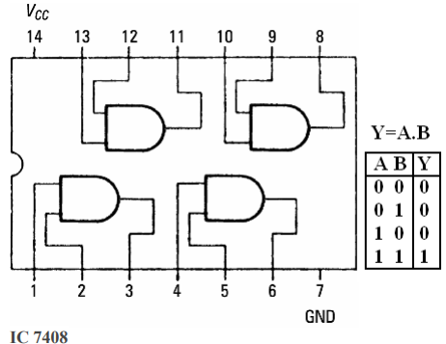

OR Gate OR gate produces an output as 1, when any or all its inputs are 1; otherwise the output is 0. This gate can have minimum 2 inputs but output is always one. Its output is 0 when all input are 0.

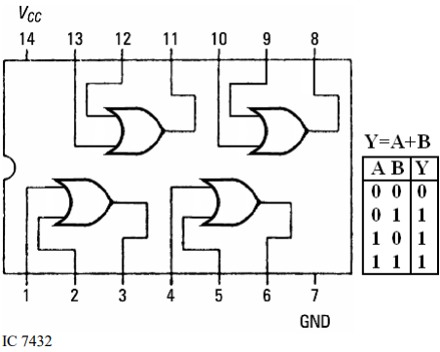

NOT Gate :

NOT gate produces the complement of its input. This gate is also called an INVERTER. It always has one input and one output. Its output is 0 when input is 1 and output is 1 when input is 0.

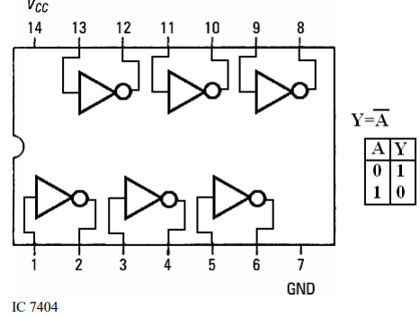

NAND Gate :NAND gate is actually a series of AND gate with NOT gate. If we connect the output of an AND gate to the input of a NOT gate, this combination will work as NOT-AND or NAND gate. Its output is 1 when any or all inputs are 0, otherwise output is 1.

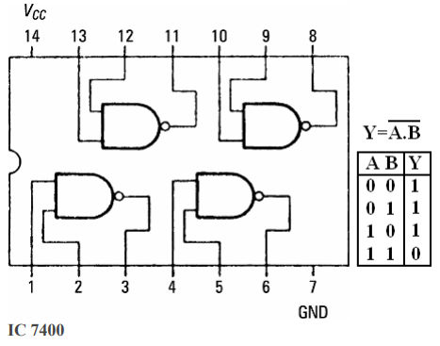

NOR Gate NOR gate is actually a series of OR gate with NOT gate. If we connect the output of an OR gate to the input of a NOT gate, this combination will work as NOT-OR or NOR gate. Its output is 0 when any or all inputs are 1, otherwise output is 1.

